Borehole No. GM76
Location Akakyi, Afram Plains
Latitude N 07°04.106’
Longitude W000°32.867’
Date started --/01/2000
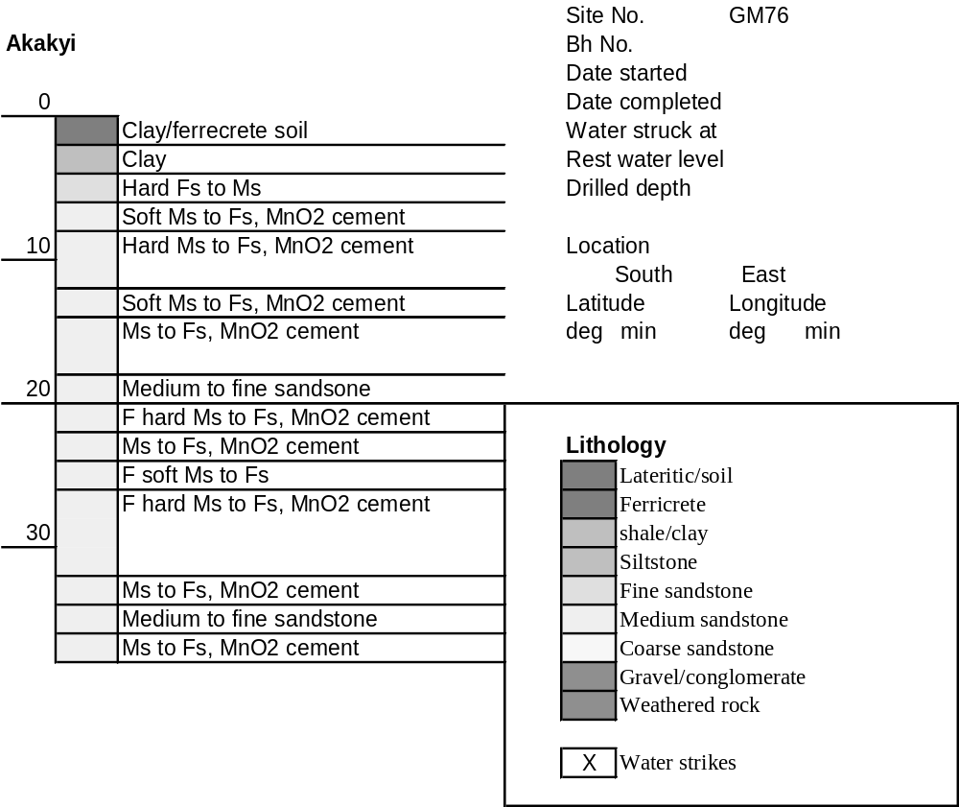Date completed 28/01/2000

Summary Lithological Log
Depth(m)
From To
0 1 Soil of clay and ferrecrete
1 3 Clay
3 4.1 Clay above very weathered soft to hard sandstone
4.1 5.1 Hard fine sandstone with manganese cement
5.1 6.1 Soft weathered medium to fine sandstone some manganese cement
6.1 8.1 Medium to fine sandstone
8.1 9.1 Hard medium to fine sandstone
9.1 10.2 Fairly soft to hard medium to fine sandstone with manganese cement
10.2 13.2 Fairly hard medium to fine sandstone with manganese cement
13.2 14.2 Very soft to hard medium to fine sandstone with manganese cement
14.2 17.3 Medium to fine sandstone with manganese cement
17.3 20.3 Medium to fine sandstone
20.3 22.4 Fairly hard medium to fine sandstone with manganese cement
22.4 24.4 Medium to fine sandstone with manganese cement
24.4 25.4 Fairly soft medium to fine sandstone
25.4 32.5 Fairly hard medium to fine sandstone with manganese cement
32.5 34.5 Medium to fine sandstone with manganese cement
34.5 35.6 Karst weathered medium to fine sandstone
35.6 37.6 Medium to fine sandstone with manganese cement

Detailed Lithological Log
Depth(m) Lithology
From To

Soil of clay and ferrecrete
0 1 Pinkish white kaolin clay with orange ferricrete nodules with dark
brown and black Fe and Mn oxide cores

Clay
1 2 Pink/white to white kaolin clay with odd nodule with black MnO core
and orange partings
2 3 Light yellow white to light ochre kaolin clay with black manganiferous
nodules and orange partings

Clay above very weathered soft to hard sandstone
3 4.1 Light ochre/white kaolin clay with orange partings above weathered
dark brown/orange soft to hard sandstone

Hard fine sandstone with manganese cement
4.1 5.1 Hard dark brown to black fine grained manganiferous sandstone

Soft weathered medium to fine sandstone some manganese cement
5.1 6.1 Brown/pink to dark brown/pink fairly soft medium to fine grained
sandstone with pink/orange grains and some black MnO along bedding
planes

Medium to fine sandstone
6.1 7.1 Dark red/brown ferruginous medium to fine grained sandstone with
some pink/orange grains
7.1 8.1 Dark red/brown medium to fine grained sandstone, some MnO cement
within finer grained patches

Hard medium to fine sandstone
8.1 9.1 Hard red/brown medium to fine grained ferruginous sandstone with
pink/orange grains and odd mica fragment

Fairly soft to hard medium to fine sandstone with manganese cement
9.1 10.2 Red/brown to dark red/brown fairly soft medium to fine grained
sandstone, fragmented pink/orange grains, little MnO black cement;
subordinate very hard grey medium to fine sandstone with much mica

Fairly hard medium to fine sandstone with manganese cement
10.2 11.2 Hard dark red/brown fairly hard medium to fine grained sandstone
with fragmented orange brown grains; harder and darker where black
MnO cement is present
11.2 12.2 Dark brown ferruginous medium to fine grained sandstone with
fragmented orange grains and some black MnO cement
12.2 13.2 Dark red/brown fairly hard medium to fine grained sandstone, harder
where black MnO cement is present

Very soft to hard medium to fine sandstone with manganese cement
13.2 14.2 Dark red/brown medium to fine grained sandstone, very soft to hard;
subordinate hard black/brown fine grained manganiferous sandstone

Medium to fine sandstone with manganese cement
14.2 15.2 Dark red/brown ferruginous medium to fine grained sandstones, some
black MnO cement; subordinate orange and grey medium grained
sandstone with grey mica rich partings
15.2 16.3 Dark red/brown to orange/grey fairly soft medium to fine grained
sandstone with little MnO cement in some layers
16.3 17.3 Dark red/brown ferruginous medium to fine grained sandstone,
fragmented pink/orange grains, harder where more black MnO cement
is present

Medium to fine sandstone
17.3 18.3 Dark brown to purple/brown medium to fine grained sandstone with
some fragmented orange grains
18.3 19.3 Dark brown to purple/brown medium to fine grained sandstone with
some fragmented orange grains
19.3 20.3 Dark red/brown medium to fine grained sandstone with fragmented
orange grains and some black MnO cement

Fairly hard medium to fine sandstone with manganese cement
20.3 21.3 Dark red brown fairly hard to hard medium to fine grained sand with
fragmented orange grains and some black MnO cement
21.3 22.4 Dark red brown fairly hard to hard medium to fine grained sand with
fragmented orange grains and some black MnO cement

Medium to fine sandstone with manganese cement
22.4 23.4 Dark purple/brown ferruginous medium to fine sandstone with some
black MnO cement
23.4 24.4 Dark purple/brown ferruginous medium to fine sandstone with some
black MnO cement

Fairly soft medium to fine sandstone
24.4 25.4 Fairly soft dark orange/brown medium to fine grained sand,
ferruginous with fragmented orange grains

Fairly hard medium to fine sandstone with manganese cement
25.4 26.4 Dark orange/brown medium to fine fairly hard sandstone, with
fragmented orange grains and some black MnO cement; odd light blue
grey mudstone/chlorite fragment, and dark red mudstone fragment
26.4 27.4 Dark brown/orange fairly hard medium to fine sandstone, with
fractured orange grains and some black MnO cement
27.4 28.4 Dark brown/orange fairly hard medium to fine sandstone, with
fractured orange grains and some black MnO cement; with thin layer
of grey micaceous sandstone with greenish chloritic stain
28.4 29.5 Purple/brown and black hard medium to fine sandstone with some
orange grains and black MnO cement; subordinate orange and grey
hard medium grained sandstone
29.5 30.5 Dark purple/brown medium to fine hard sandstone with orange grains
and black MnO cement and mica?
30.5 31.5 Dark red/brown medium to fine sandstone, fairly hard with fragmented
orange grains; subordinate hard black/brown manganiferous fine
grained sandstone
31.5 32.5 Dark red/brown medium to fine sandstone, fairly hard with fragmented
orange grains; subordinate hard black/brown manganiferous fine
grained sandstone

Medium to fine sandstone with manganese cement
32.5 33.5 Dark purple/red cross bedded medium to fine grained sandstone, some
black MnO cement
33.5 34.5 Dark purple/red medium to fine grained sandstone with some black
MnO cement; subordinate dark orange grey medium to fine grained
sandstone with little black MnO cement

Karst weathered medium to fine sandstone
34.5 35.6 Dark red/grey medium to fine grained cross bedded Karst weathered?
sandstone

Medium to fine sandstone with manganese cement
35.6 36.6 Purple/red compact cross-bedded medium to fine grained sandstone
with black MnO on bedding planes
36.6 37.6 Purple/brown medium to fine grained sandstone, some black MnO
cement and orange grains. Cross-bedded with black mica on bedding
planes with orange oxidation spots

